PROJECT SYNOPSIS
INTRODUCTION
- The Objective of the “GYM Management System” is to provide a system which handles the information of the people coming into gym and maintaining their health care. It maintains the data and all the details of the equipments used by the people who join the gym.
- Data will be stored in the database. To also maintain customer details, trainer details, gym records. The admin is able to view all the members of the fitness centre as well as their details.
- The system will perform the task like adding the new member to the gym, removing the member and keeping the payment records
- The system which helps the administration in speeding up the tasks at the same time reducing complexity.

OBJECTIVES OF THE PROJECT
- This project is an web based application for the “Patils Fitness Gym Dharwad” we are providing this web site which will keep the track of all information like customer details, trainer information and equipments details etc.
- Manages the trainers in a better way.Easy to find the various information related to customers and trainers. Maintains the date of joining and leaving.Administrator will get accurate details.

1.1 PRESENT SYSTEM
- Existing system was manual.
- Time consuming as data entry which include calculations took lot of time.
- Searching was very complex as there could be 100’s of entry every year.
- This Manually managed system of the store was also heavily proned to data loss due to certain causes Misplacement of Registers, Destruction of Registers ,Unauthorized access to registers etc. which can bring in disastrous Consequences.
- The cost of maintains of data and records of occurrence of transactions is very high

1.2 PROPOSED SYSTEM
- The Admin has the full-fledged rights over this system.
- The admin can register and view the customer profile data.
- Admin will update evaluation report of customer, update diet plan, update exercise schedule.
- Customer can view the profile data can update it by using his own account
- Customer can view their evaluation report, updated diet plan, updated exercise schedule

INPUT OF THE PROJECT
- Admin details
- Customer details
- Trainer details

OUTPUT OF THE PROJECT
- Payment details
- Salary details

PROCESS LOGIC
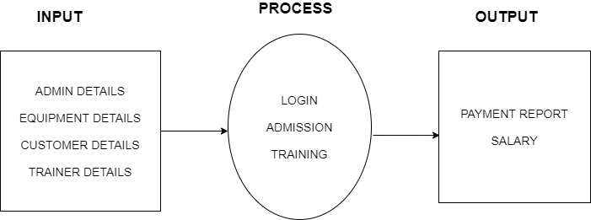

DFD
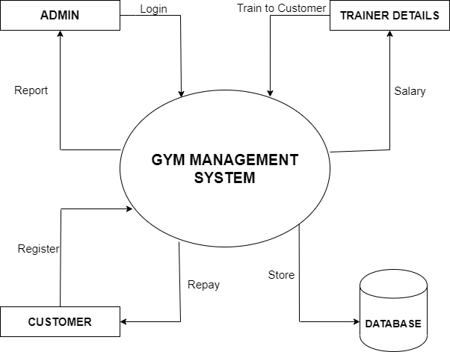

Hardware required for the project
Processor : Intel -III based system
Processor Speed : min 250 MHz to max 833MHz
. RAM : min 64MB to max 256MB.
Hard Disk : min 10GB free space

Software required for the project
Language : PHP

Database : MS SQL Server200
Operating System : Windows XP or Above
Front End : HTML, Dream Weaver, CSS.
Back End : My SQL
Middleware : PHP
Server : WAMP Server

ARE YOU DOING THIS PROJECT FOR ANY INDUSTRY OR CLIENT? IF YES ACCEPTANCE OF THIS PROJECT:
- Yes, Patil’s Gym Dharwad

DURATION OF THE PROJECT:
- 2 Months

MEMBERS OF THE PROJECT: 2 Members
- Roopa Fakkirappa Amatennavar [17U11211]
- Vakalapudi Mounika [17U11264]

LIMITATIONS OF PROJECT:
- No advanced payment such as internet banking ,credit card ,debit card payment system.
- No multi language support.
- The transcations are executed in offline mode, hence online data capture and modification is not possible.
SCOPE OF FUTURE APPLICATION:
- Multiple languages can be implemented.
- Advanced payment such as internet banking can be implemented.
- Android application can be made further.

